Cristian Jaramillo

cdjaramillo2192@gmail.com

THE HUNTER V 1.0

YOU CAN SURVIVE?

**Description**

The Hunter is a 2D RPG video game when you control Hak and try to survive in this world.

# Game Design English

The Hunter V 1.0

Cristian David Jaramillo Calle

Group: 1319447

Víctor Hugo Cardona

Alejandro Díaz Jaramillo

(Instructor)

SERVICIO NACIONAL DE APRENDIZAJE

Centro de servicios y gestión empresarial

Industrias creativas

Medellin

2018

**Table of Content**

Game Design 0

SECTION 1 – SUMMARY OF THE VIDEO GAME. 3

HIGH CONCEPT. 3

CHARACTERISTICS. 3

GENRE. 3

TARGET AUDIENCE. 3

VISUAL STYLE 3

SCOPE OF THE PROJECT. 4

SECTION 2 – HISTORY, ENVIROMENT AND CHARACTERS: 5

DINOSAURS: 5

HISTORY AND NARRATIVE 6

NARRATIVE DESIGN 6

SECTION 3 – GAMEPLAY AND MECHANICS OF THE VIDEO GAME 7

OBJECTIVES 8

MECHANICS 8

PHYSICS 9

MOVEMENTS 9

OBJECTS 9

SECTION 4 – LEVELS 10

ENVIROMENT 11

SECTION 5 – INTERFACES 12

GRAPHICAL USER INTERFACES 12

ENTRY DEVICE 12

SOUNDS 12

SECTION 6 – TECHNICAL ASPECTS 13

DEVELOPMENT HARDWARE AND SOFTWARE 13

SECTION 7 – DEAL 14

MONETIZATION 14

PLATFORM 14

# SECTION 1 – SUMMARY OF THE VIDEO GAME.

## HIGH CONCEPT.

**YOU CAN SURVIVE?**

The Hunter is a 2D RPG video game when you control Hak and try to survive in this world.

## CHARACTERISTICS.

Principal characteristics:

* Explore a 2D scenarios and interact with some NPC and destroy enemies.
* The game is intended for Windows.
* The video game makes use of the keyboard keys and the output device is the screen when the player can see the information.

## GENRE.

The game belongs to RPG and Action Games.

## TARGET AUDIENCE.

The game is E for everyone, any person plays the game.



## VISUAL STYLE

The graphic style of the game is made up of 2D sprites models, its type of camera is orthogonal since the user can move in any direction but a view for the sky.

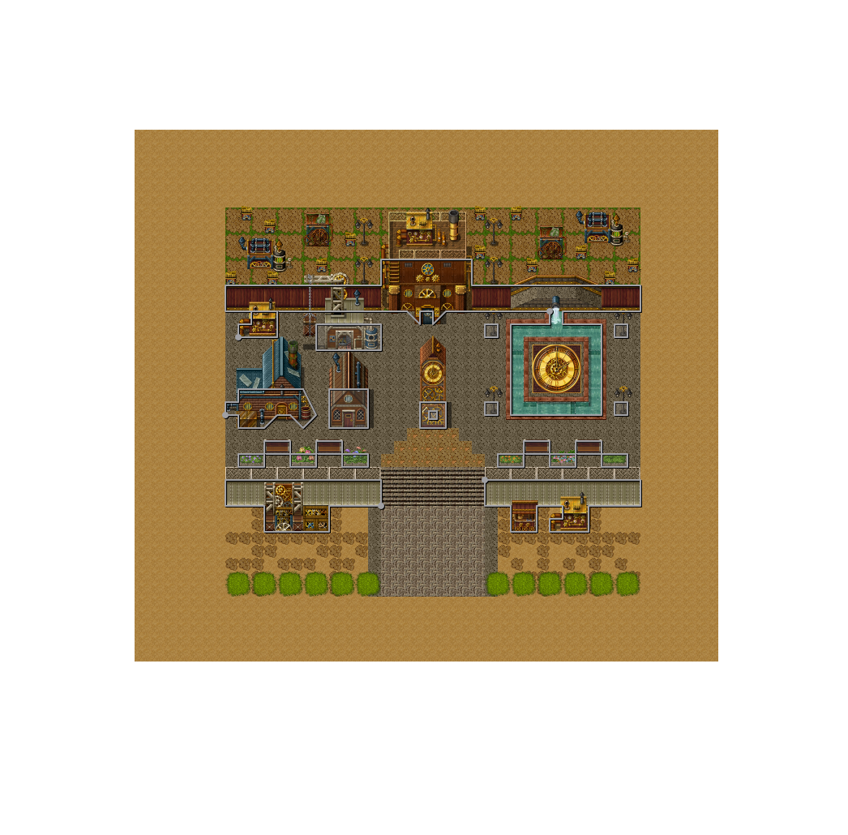

*Thanks to* [***Christian David Hurtado Monroy***](https://www.behance.net/christian_hurtado) *for the scenario*

## SCOPE OF THE PROJECT.

At the end of the development of the game it is planned to deliver two scenes of the game and some NPC interaction and quest.

# SECTION 2 – HISTORY, ENVIROMENT AND CHARACTERS:

The characters of the game are NPC, some enemies and the player.

## CHARACTERS OF THE GAME:

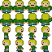**Hak**

Measurements: 180cms.

Weight: 75KG

Aged: 29 years.

Profile: Hak is a hunter of monsters and like to slay every monster in the world

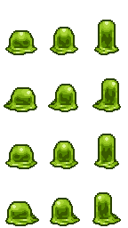**Slimes**

Found in: A strange world.

Measurements: Unknown.

Weight: Unknown.

Years: Unknown

Profile: The slimes are slug compositions that roam the world but can be dangerous

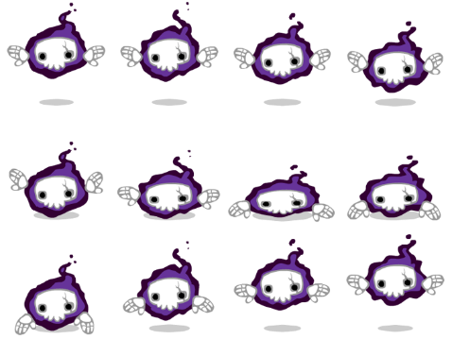**Ghosts**

Found in: Strange world

Measurements: ¿?

Weight: ¿?

Years: ¿?

Profile: The ghosts of this world are dangerous, have a great live and move faster.

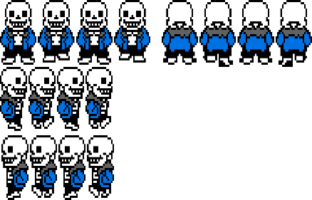**SKELETON**

Measurements: 180cm

Weight: ¿?

Years: ¿?

Profile: The skeleton are a passive enemy characters who offers dialogue to Hak, they live in the underground city.

**WEREWOLF**

Measurements: 200cm

Weight: 180KG

Years: ¿?

Profile:

## HISTORY AND NARRATIVE

The Hunter consists in make the best score and complete the quest in the game.

## NARRATIVE DESIGN

It will be counted by the NPC informing to Hak what happened in this strange world.

# SECTION 3 – GAMEPLAY AND MECHANICS OF THE VIDEO GAME

The player has control over Hak to move around the camp and the underground city interacting with the NPC and the enemies.

Screen flow of the game:

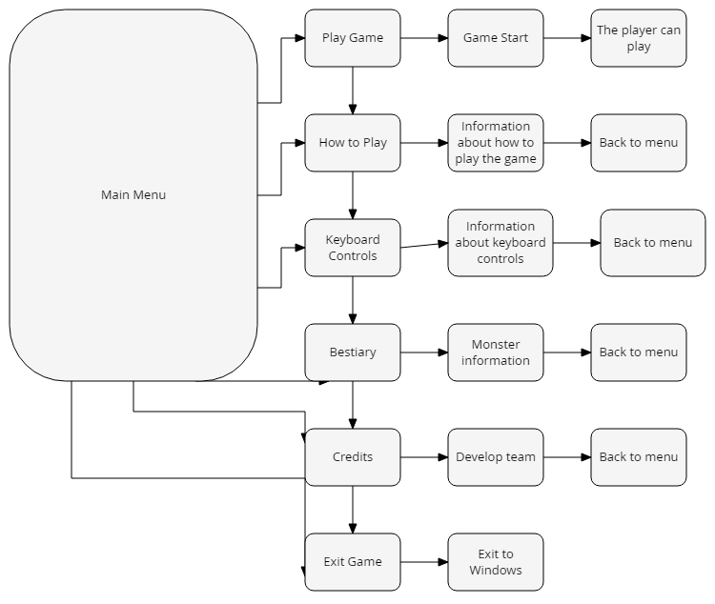

Game Flow of the game

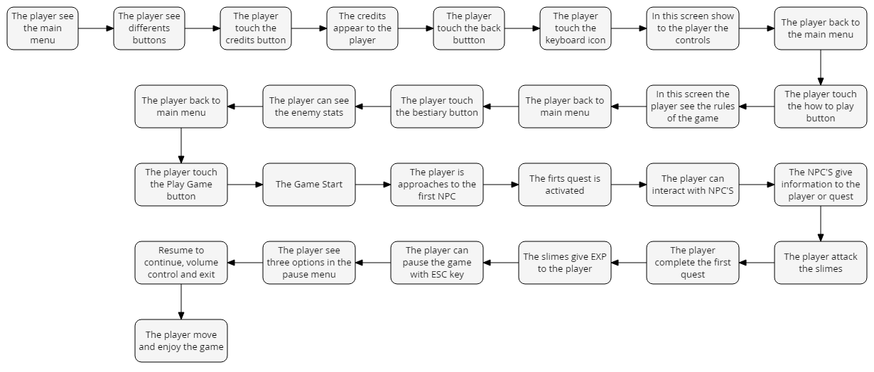

Windows Keyboard Scheme

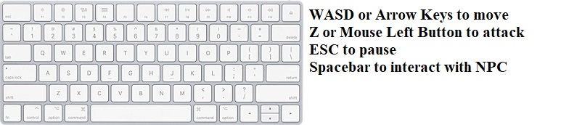

## OBJECTIVES

The objective of The Hunter is that the player enjoys a 2D RPG Game.

## MECHANICS

The mechanics are simple, the player can move in any eight directions using the keyboards keys, so he can move in any direction on the map.

## PHYSICS

When the player is hurting by enemies a number on the screen appear that indicates the damage deal by enemies, also the player blink for a second, if the player deals damage to an enemy the same number appears indicate the damage of the enemy.

## MOVEMENTS

The player can move to any direction of the game using the respective keys.

## OBJECTS

It will feature 2D RPG Game where the player can move and interact with NPC and enemies also take quest or trying the best score.

# SECTION 4 – **LEVELS**

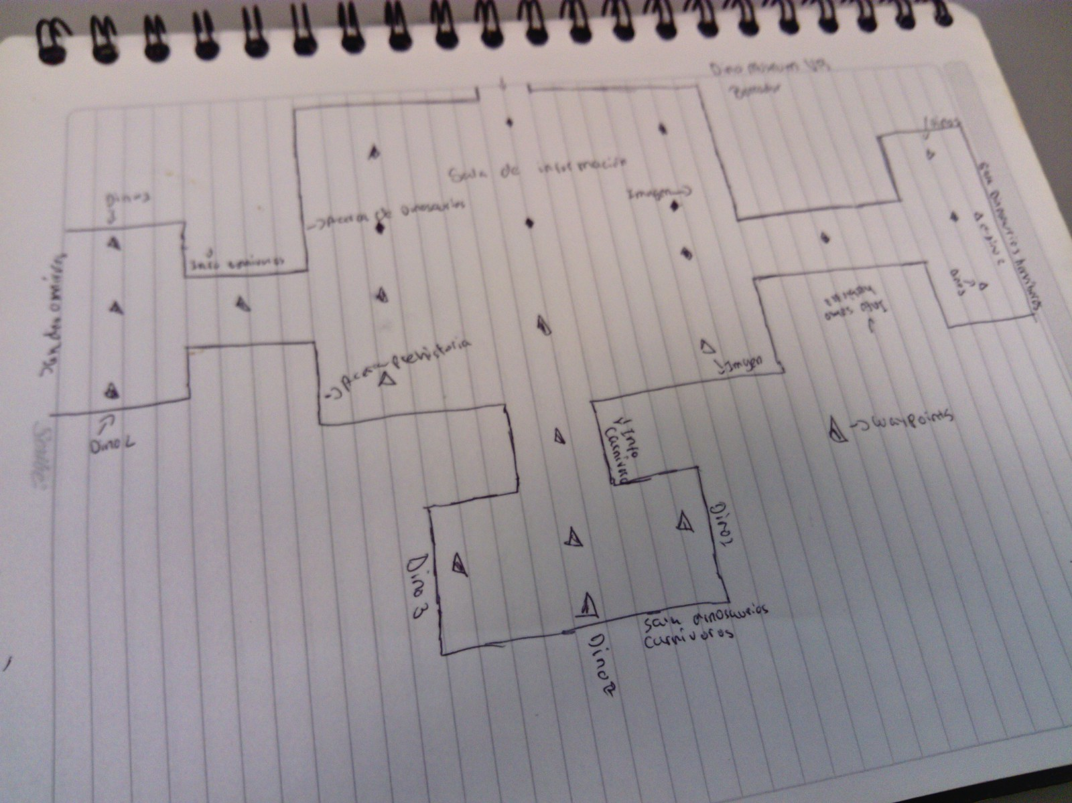

## ENVIROMENT

The player starts in a camp with the NPC, there is also a tent, but this tent is not what is seems because the tent is a portal to the underground city take it by slimes and ghosts.

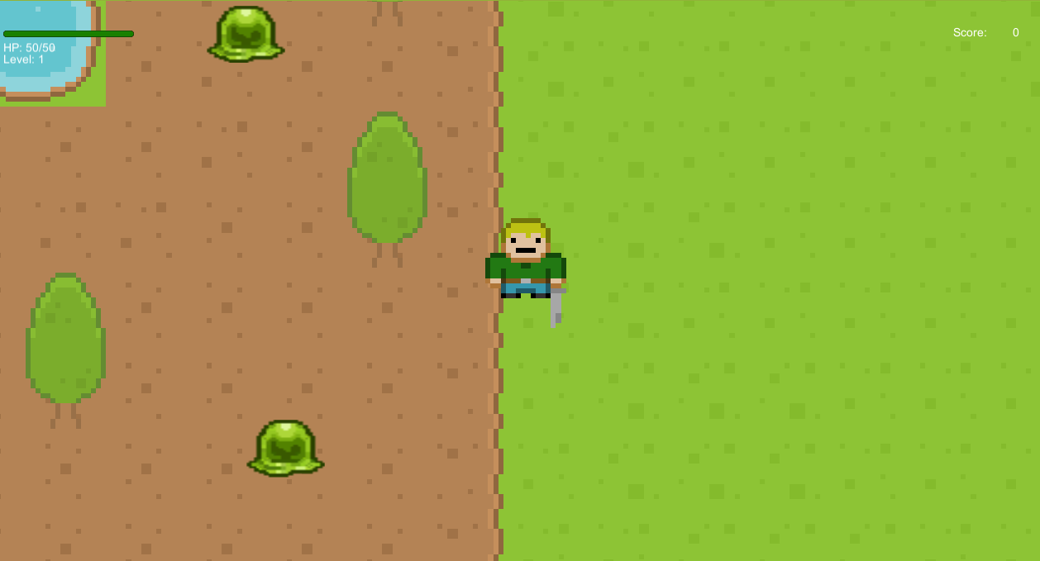

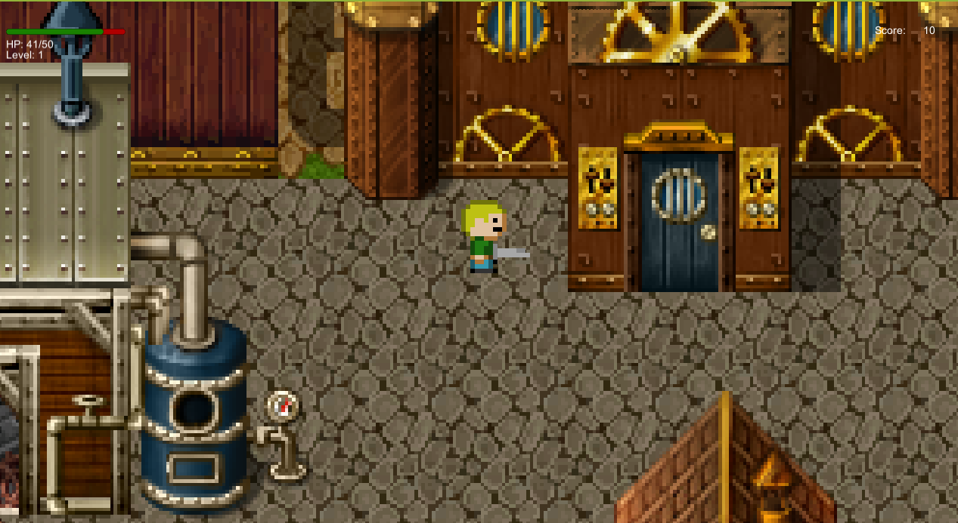

# SECTION 5 – INTERFACES

## GRAPHICAL USER INTERFACES

In the scene the player can see a green bar on the left screen if the green bar is red the player is taking damage and the HP numbers change, if the player slays enemies he can gain levels (10 levels for now) and the strength, defense and HP increase.

In the right side of the screen there is a score system, this system provides the player the number of points in the game

 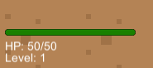

## ENTRY DEVICE

The input device is PC since this is the one that will make the program run and show on the screen all the video game.

## SOUNDS

There are many SFX sounds for the game, like sword, player receives damage, and music

# SECTION 6 – TECHNICAL ASPECTS

The Hunter is for Windows systems, Windows 7 or above to run the game.

Requirements:

Windows 7/8/8.1/10 x86 or x64

Processor: Intel Pentium or AMD Athlon or above

HDD: 50MB minimum

Graphic card: Intel HD 5500 or Nvidia and AMD derivate.

## DEVELOPMENT HARDWARE AND SOFTWARE

|  |  |
| --- | --- |
| Component | Model |
| Processor | Intel Core i3-5005U @2GHz |
| RAM | 4GB DDR3 |
| Motherboard | 80E4 |
| Display | Lenovo G40 17” |
| Peripherals | Mouse, keyboard |
| Hard drive disk | 1TB |
| Graphic card | Intel HD Graphics 5500 2GB |
| Operating System (OS) | Windows 10 Professional X64 |
| Game engine | Unity 5.6 |

# SECTION 7 – DEAL

## MONETIZATION

Is a free game and only for educational.

## PLATFORM

The platform where a publication disclosing our project and can be tested by any non-profit person is saved on GitHub.